MP Project Report on
FAKE REVIEW DETECTION
at
U.V. Patel College of Engineering


Project Guide: Prepared by :
Dr.Pravesh Patel Honey B Patel(22012021065)
Preya P Patel (22012011087)
Yash K Patel(22012021102)

B.Tech Semester VII
Submitted to,
Department of Computer Engineering/Information Technology
U. V. Patel College of Engineering
Ganpat University, Ganpat Vidyanagar - 384 012

U.V. PATEL COLLEGE OF ENGINEERING

C E R T I F I C A T E

TO WHOM SO EVER IT MAY CONCERN

This is to certify that Ms. Honey B Patel student of B.Tech. Semester VII (Information Technology) has completed her full semester Minor Project titled “Fake Review Detection” satisfactorily in partial fulfillment of the requirement of Bachelor of Technology degree of Information Technology at Ganpat University, Ganpat Vidyanagar, Mehsana in the year 2025.

Project Guide

Sign Dr. Devang Pandya
Dr. Pravesh Patel Head, Information Technology

U.V. PATEL COLLEGE OF ENGINEERING

C E R T I F I C A T E

TO WHOM SO EVER IT MAY CONCERN

This is to certify that Ms. Preya P Patel student of B.Tech. Semester VII (Computer Engineering) has completed her full semester Minor Project titled “Fake Review Detection” satisfactorily in partial fulfillment of the requirement of Bachelor of Technology degree of Computer Engineering at Ganpat University, Ganpat Vidyanagar, Mehsana in the year 2025.

Project Guide

Sign Dr. Paresh M.Solanki
Dr. Pravesh Patel Head, Computer Engineering

U.V. PATEL COLLEGE OF ENGINEERING

C E R T I F I C A T E

TO WHOM SO EVER IT MAY CONCERN

This is to certify that Mr. Yash K Patel student of B.Tech. Semester VII (Information Technology) has completed her full semester Minor Project titled “Fake Review Detection” satisfactorily in partial fulfillment of the requirement of Bachelor of Technology degree of Computer Engineering at Ganpat University, Ganpat Vidyanagar, Mehsana in the year -2025.

Project Guide

Sign Dr. Devang Pandya
Dr. Pravesh Patel Head, Information Technology

CHAPTER 1: INTRODUCTION

1.1 Project Overview
A Fake Review Detection System is a software solution developed to identify and filter out deceptive or misleading product and service reviews. It provides an easy-to-use interface where review text and related information (such as reviewer ID, rating, product ID, etc.) are analyzed using natural language processing and machine learning techniques to check whether a review is genuine or fake.
The main focus of this project is on review classification, which includes steps like data collection, text preprocessing, feature extraction, and applying classification models to detect suspicious patterns. The system also considers factors like review sentiment, posting behavior, and metadata to improve accuracy. In addition to detection, it can provide feedback such as highlighting suspicious phrases or unusual reviewer activity.
This system is useful for e-commerce platforms, travel sites, and service-based businesses, as it helps build trust by ensuring customers see authentic reviews. By reducing the influence of fake reviews, the project supports fair competition, improves decision-making for users, and enhances the overall credibility of online platforms.

1.2 Project Background
With the rapid growth of online shopping, travel services, and digital platforms, customer reviews have become an important factor in decision-making. However, the increasing number of fake or misleading reviews has created challenges for both businesses and consumers, leading to loss of trust and unfair competition. This project is developed to address these issues by using modern technologies like machine learning and natural language processing to detect fake reviews effectively. It builds on advancements in data analysis and automation, offering a reliable solution to improve transparency, protect genuine customers, and support fair business practices.

1.3 Purpose
The purpose of this project is to:
- Develop a system that can detect and filter fake or misleading reviews with high accuracy.
- Provide a simple and user-friendly platform for analysing reviews.
- Help businesses maintain trust and credibility by ensuring only genuine reviews are highlighted.
- Assist customers in making better decisions based on reliable feedback.
- Support fair competition among businesses by reducing the impact of fake reviews.

  - Problem Statement
In existing online platforms, there is a growing problem of fake or misleading reviews that reduce customer trust and affect business credibility. Many current systems only display reviews without verifying their authenticity, which allows spam, biased, or paid reviews to influence customer decisions. This not only misguides genuine customers but also creates unfair advantages or disadvantages for businesses. The lack of an effective detection mechanism makes it difficult to maintain transparency and reliability in review platforms. Therefore, there is a need for a system that can automatically identify and filter fake reviews in a simple and accurate way.

  - Tools and Technologies
The project will leverage the following tools and technologies:
- Frontend:
- Backend: Python for handling server-side operations.
- Database: MongoDB for storing database of yelp.
- APIs:
- Version Control:
- Design Tools: Figma/Adobe XD for UI/UX design prototypes.

CHAPTER 2: PROJECT SCOPE
2.1 Objective
Develop an efficient and user-friendly Fake Review Detection System that can analyze and classify reviews as genuine or fake. The system should cater to different user roles, including customers, businesses, and administrators, ensuring secure, real-time detection of suspicious reviews to maintain trust and transparency on online platforms.

2.2 Key Features
- Review Analysis and Detection
    - Analyse review text, ratings, and metadata to identify fake or misleading reviews.
    - Classify reviews as genuine or suspicious in real time.
    - Provide confidence scores or alerts for suspicious reviews.

- User Management
    - Customer registration and login to submit and view reviews.
    - Profile management for customers to track their activity and feedback.
    - Admin role to monitor flagged reviews and manage users.

- Review Management
    - View, approve, or remove reviews based on detection results.
    - Allow users to report suspicious reviews manually.
    - Maintain a history of flagged and verified reviews.

- Business Support
    - Help businesses monitor the authenticity of reviews on their products/services.
    - Provide insights into review quality and customer trust.
    - Generate reports on fake review trends for business improvement.

- System Integration (Admin)
    - Integration with e-commerce or review platforms.
    - Regular updates of detection models for improved accuracy.
    - Dashboard to view analytics, suspicious activity, and system performance.

2.3 Technology Stack
- Frontend:
- Backend: Python
- Database: MongoDB
- API Integration:

2.4 Expected Outcome:
- A robust, accurate, and user-friendly Fake Review Detection System that improves customer trust, helps businesses maintain credibility, and ensures fair competition by filtering out misleading reviews.

CHAPTER 3: FEASIBILITY ANALYSIS
3.1 Technical Feasibility
- The technical feasibility of the Fake Review Detection System is strong, as it relies on widely available and proven technologies. Using programming languages like Python along with machine learning libraries (such as Scikit-learn, TensorFlow, or NLTK), the system can be developed effectively. Reliable databases like MongoDB can be used to store and manage review data. The system can also be deployed on scalable cloud platforms, ensuring it can handle large volumes of reviews in real time. With natural language processing techniques and machine learning models, detecting fake reviews becomes efficient, accurate, and practical.

3.2 Time Schedule Feasibility
- The time schedule feasibility for the Fake Review Detection System is practical, with development divided into clear phases. The initial phase—data collection, preprocessing, and building basic machine learning models—can be completed in 2–3 months. The next phase may include developing the user interface, review management features, and integration with platforms, which may take an additional 2–3 months. Final stages involving testing, model optimization, bug fixing, and deployment can be completed in 1–2 months. Overall, the system can be developed and launched within 5–8 months using an agile approach, allowing room for feedback and improvements.

3.3 Operational Feasibility
- The Fake Review Detection System is designed to improve trust and reliability on online platforms by providing an easy-to-use and efficient way to filter reviews. Its simple interface makes it convenient for customers to view genuine reviews and for businesses to monitor feedback. On the operational side, the system automates the process of analyzing and detecting fake reviews, reducing the need for manual moderation. Feedback and flagged reports can be used to continuously improve model accuracy and system performance, making it operationally feasible and sustainable in real-world use.

3.4 Implementation Feasibility
- The implementation feasibility of the Fake Review Detection System is high, as the required technologies, tools, and skilled developers are readily available. The system can be implemented in modular phases—starting with core functions like data collection and preprocessing, followed by building and training detection models, and then developing the user interface and integration features. Cloud platforms such as AWS or Azure can be used for secure and scalable deployment. With proper planning, access to datasets, and proven development methods, the project can be implemented smoothly within the planned time and resources.

3.5 Economic Feasibility
- While there will be initial costs for development, data collection, server hosting, and model training, the Fake Review Detection System has strong potential for long-term benefits. It reduces the need for manual review moderation, saving both time and operational costs. By increasing customer trust and protecting business credibility, it helps platforms attract and retain more users. Over time, improved reliability and transparency will enhance business growth, making the system economically feasible and sustainable in the long run.

CHAPTER 4: SOFTWARE AND HARDWARE REQUIREMENTS
4.1 Minimum Hardware Requirements
- Operating System: Windows 10 or later
- Processor: Intel i5 (5th generation or higher)
- RAM: Minimum 4 GB (8 GB recommended)
- Processor Speed: 2.0 GHz or higher
- Hard Disk Space: At least 80 GB

4.2 Minimum Software Requirements (Tools & Technology)
- Web Application:
- Backend Server: Node.js
- Database: MongoDB
- Push Notifications: Firebase Cloud Messaging (FCM)
- Geolocation Services: Google Maps API or Map box
- Third-Party APIs: Skyscanner or Amadeus for flight data, Stripe or PayPal for payments
- Security: Spring Security, TLS/SSL, OWASP Dependency-Check

4.3 Development Tools
- IDE: VS Code or any modern integrated development environment.
- Version Control: Git for version management.
- Testing Tools: Mocha, Chai for unit tests; Selenium for integration tests.
- Deployment: AWS or Digital Ocean for cloud hosting and deployment.

CHAPTER 5: PROJECT MODEL
5.1 Reason to Use the Iterative Model
The Iterative Process Model is highly suitable for the Fake Review Detection System because it supports step-by-step development, continuous improvement, and user feedback integration. Key features such as data collection, preprocessing, model training, review classification, and admin controls need regular refinement to improve accuracy and reliability. This model allows the system to be built in small cycles, where each phase is tested and enhanced before moving to the next. By testing detection accuracy, improving algorithms, and adjusting features based on real data and feedback, the system becomes more stable, accurate, and user-friendly. This flexibility is important for handling evolving datasets, adapting to new types of fake reviews, and ensuring trust and satisfaction for both customers and businesses.

5.2 Project Phases
- Initial Planning
Objective: Define the core scope and vision of the Fake Review Detection System.
Activities:
  - Analyze the problem of fake reviews and their impact on businesses and customers.
  - Identify goals such as detecting fake reviews accurately, building user trust, and supporting business credibility
  - Recognize key stakeholders (Admins, End Users, Businesses).
  - Plan task allocation for data collection, model development, and system design.

- Planning
Objective: Organize the first development iteration and outline feature prioritization.
Activities:
  - Break the system into modules – Data Collection, Preprocessing, Detection Model, Admin Dashboard, User Interface.
  - Prioritize key functionalities – Review Detection, Classification, and Reporting.
  - Assign tasks for backend (data & model), frontend (UI design), and integration (dashboard & analytics).

- Requirements
Objective: Gather functional and non-functional requirements from stakeholders.
Activities:
  - Conduct discussions with customers, admins, and businesses to define expectations (e.g., accuracy, transparency, usability).
  - Identify system inputs (review text, rating, metadata), processes (preprocessing, model prediction), and outputs (genuine/fake label, alerts).
  - List priority modules – Detection Engine, Admin Review Management, User Feedback.

- Analysis & Design
Objective: Design the system architecture and components for the first cycle.
Activities:
  - Create architecture covering frontend (UI), backend (detection model, APIs), and database.
  - Define database schema (Users, Reviews, Detection Results, Reports).
  - Design wireframes for user and admin dashboards.
  - Plan secure handling of user data and review storage.

- Implementation
Objective: Develop and integrate system features as per the current cycle.
Activities:
  - Build backend modules for preprocessing, detection logic, and user authentication.
  - Develop the admin panel to manage flagged reviews and generate reports.
  - Implement frontend interfaces for review submission and results display.
  - Integrate detection model with the system for real-time analysis.

- Testing
Objective: Validate accuracy and performance of implemented modules.
Activities:
    - Perform unit and integration testing on review submission, detection, and admin controls.
    - Test model accuracy, false positive/negative rates, and system reliability.
    - Conduct performance testing with large review datasets.
    - Fix issues and document results for the next iteration.

- Evaluation
Objective: Review iteration outcomes with stakeholders.
Activities:
  - Demonstrate working modules – Detection Engine, Admin Dashboard, Review Reports.
  - Collect feedback on detection accuracy, usability, and reporting features.
  - Identify improvement areas and new requirements for the next cycle.

- Deployment
Objective: Release the current version for testing or limited live usage.
Activities:
  - Deploy the system on a local or cloud server for controlled access.
  - Allow test users (Admins, Businesses, Users) to interact with the system.
  - Monitor detection performance, collect logs, and prepare documentation for further development

CHAPTER 6: PROJECT PLANS

6.1 List of major activities and estimated time duration in weeks.

Table 6.1 – Project Planning

Sr. No. | Major Activities | Estimated Duration (Weeks) | Weeks
1. | Requirements Gathering & Analysis | 2 weeks | 1-2
2. | System Design (UI/UX + Architecture) | 2 weeks | 3-4
3. | Data Collection & Preprocessing | 3 weeks | 5-7
4. |  | 4 weeks | 6-9  (Parallel)
  Model Development (ML/NLP algorithms)
5. |  | 3 weeks | 8-10
  Backend Development ( DB integration)
6. | Frontend Development (UI for users/admin) | 3 weeks | 9-11(Parallel)
7. | Testing & Quality Assurance | 2 weeks | 11-12
8. | Deployment & Launch (Cloud Hosting) | 1 weeks | 13
9. | Post-launch Support & Maintenance | 1 weeks +  (Ongoing) | 14 onwards

- The solution is to develop a web-based system where users can submit reviews, and the system will analyze them to detect fake or genuine reviews.
- The system will use machine learning and natural language processing to classify reviews based on text and metadata.
- It ensures real-time detection, user-friendly dashboards, and secure handling of review data.
- The platform will support scalability to handle large datasets, regular updates to improve detection accuracy, and reporting tools for admins and businesses.
- Future enhancements may include integration with e-commerce platforms, multilingual review analysis, and detailed analytics for businesses.

CHAPTER 7: SYSTEM DESIGN
7.1 Use case diagram

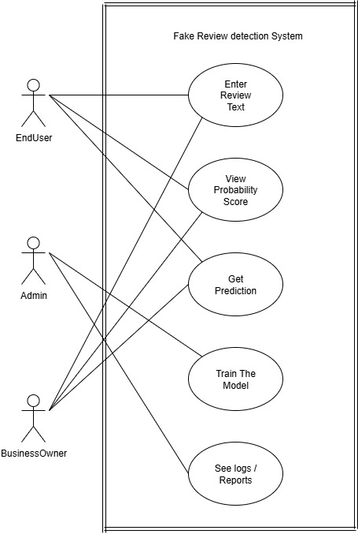

Figure 7.1 – Use Case Diagram

7.2 Class diagram
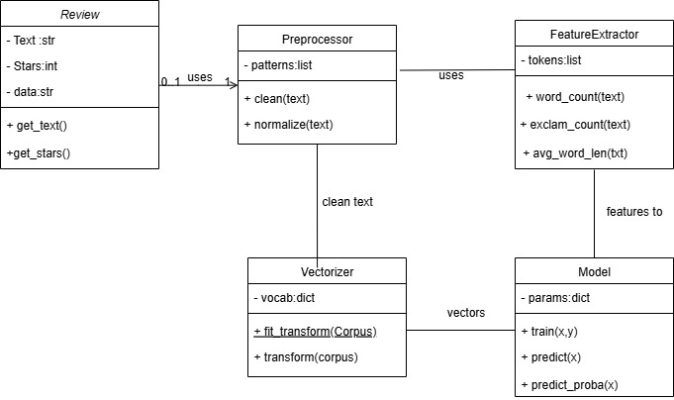

Figure 7.2 – Class Diagram
7.3 Activity diagram
(Enduser)

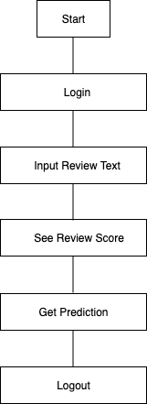

Figure 7.3 – Activity Diagram (Enduser)

(Business Owner)

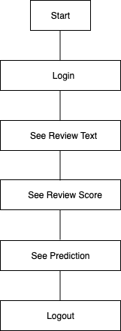

Figure 7.4 – Activity Diagram (Business Owner)

(Admin)

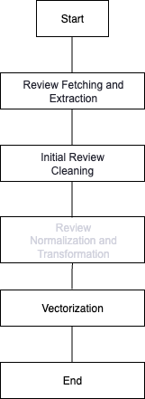

Figure 7.5 – Activity Diagram (Admin)

